Crossgates Greenfingers 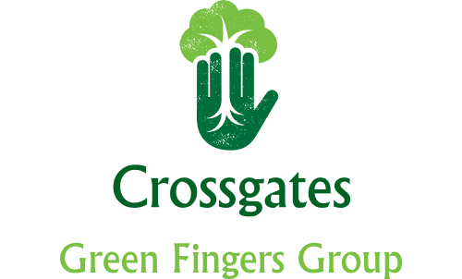

horizontal line

Pleased to see you on this cold winter’s day. It’s been another difficult year with Covid ever present which has restricted our fundraising abilities considerably. However, we have struggled on and I hope you will agree that the Village still looked bright and colourful.

I have printed off last year’s accounts which were audited by Carol Reid. They are hard to read so if anyone wants a copy emailed to them let me know.

We started off on 22nd October 2020 with a balance of £4,395.55. We have received donations in cash and kind amounting to £2,134.14; Grants of £6,152 and Sponsorship of £1,500. From this figure we have purchased a shed together with lighting and toilet facilities; erected raised beds both inside and outside the polytunnel; arranged access for water for the polytunnel and raised beds (albeit on an annual basis until funds can be found to make it permanent); the large conifer trees were cut down and removed at the community garden and specialist driveway cleaners made a fantastic job of cleaning the path; thanks to the fund raising of Kathleen Johnstone at the Crystal Corner and donations from other Village groups allowed us to purchase and erect a living Christmas Tree with Christmas lights for the Villagers to enjoy on the 25th December plus conifers and bulbs planted round about to look good throughout the rest of the year; lots of compost, manure and bark has been used throughout the Village; with insurance and website costs this left a balance of £2,122.40. Included in this amount is £550 we received from Fife Council to cover the cost for them to install an outside tap at the Institute where we can get water for the community garden but this has still to be installed.

Going forward all the plants for this year have been ordered and paid for which leaves a balance in our account £1,640. We’ve been promised £1,000 from the Masonic Lodge and we are due to get this in March.